The Title of the Paper
Times New Roman font type, 16-point, bold, centered.
Ion Popescu¹, Gheorghe Popescu² and Maria Popa³
First and last name of each author in Times New Roman font type, 11-point bold, center.
¹⁾ Author 1 affiliation: University, city, country.
²⁾³⁾ Authors 2 and 3 affiliation: University, city, country.
Times New Roman, 11-point, italic, center.
Authors affiliation: Times New Roman, 11-point, italic, center. If several authors are from the same institution, its name shall be written only once.
E-mail: author1@gmail.com; E-mail: author2@yahoo.com
E-mail: author3@hotmail.com
(Please, do not fill fields or modify text highlighted in gray)
Please cite this paper as:
Example:
Popescu, I., Popescu, Gh. and Popa, M.,2024. The Title of the Paper. In: R. Pamfilie, V. Dinu, C. Vasiliu, D. Pleșea, L. Tăchiciu eds. 2024. 10th BASIQ International Conference on New Trends in Sustainable Business and Consumption. Almeria, Spain, 6-8 June 2024. Bucharest: Editura ASE, pp. ....
DOI: …………......

The entire paper will be written using Times New Roman font type, 10-point, alignment: justify, line spacing: 1, paragraph spacing: 6 pt. before each paragraph. The length of the article cannot exceed 8 pages. Please read the recommendations carefully. Compliance with the requirements of this template is mandatory.

Abstract
The abstract must include sufficient information for readers to judge the nature and significance of the topic. It should summarize the objectives of the article, methodology, results, and conclusions. To increase the visibility of the article, the abstract should reiterate key words and expressions while avoiding unnecessary repetition and should have between 200 and 300 words.
The abstract should have the following structure:
- Purpose/objectives
- Design/methodology
- Findings
- Originality/value
- Possible practical implications
Keywords
Four to seven keywords (words or expressions) that capture the essence of your paper should be listed in decreasing order of importance, ensuring consistency with the title and the abstract of the article.
DOI: ……………...

Introduction
The body of the paper will be written using Times New Roman font type, 10-point, alignment: justify, line spacing: 1, paragraph spacing: 6 pt. before each paragraph. An empty row will be introduced before every subtitle. All subtitles will be numbered except for the introduction and the conclusions.
The introduction familiarizes the reader with the context of the paper. It must reflect, briefly, current research in the field; a minimum of three references must be cited in this section. In addition, it should state the specific research problem, describe the approach chosen by the authors and present an overview of the paper’s structure.

Paper Body
The paper should be the result of a research in the area, corresponding to the specific topic of the conference. The structure of the paper should be clear and well emphasized by titles and subtitles placed in a logical sequence, according to the writing methodology of the scientific papers. To allow the readers to understand better the work of the authors, the following structure of the paper is recommended: Review of the scientific literature, Research methodology, Results and discussion.

For unordered bulleted lists, the following format will be used:
- This is the first item on the list. In case of sub-lists, unordered lists with dashes will be used, as follows:
- first subitem
- second subitem
- Second item on the bulleted list.
- Last item on the bulleted list.
For numbered lists, please use the following format:
- This is the first item on the list. In case of sub-lists, unordered lists with dashes will be used, as follows:
  - first subitem
  - second subitem
- Second item on the bulleted list.
- Third item
Tables and figures should be placed in the body of the paper exactly where the authors want them to appear printed and be of the size desired by the authors. We recommend that the tables and figures fit on one page and be inside the margins of the paper. Graphs must be uncluttered and easy to read. Tables and figures will be numbered. The heading should be in Times New Roman font type, 10-point, bold, positioned above the corresponding table or below the corresponding figure. Please indicate the source of data when appropriate (in Times New Roman font type, 10-point, italic, center, above the table or below the figure). Use References/Insert Caption to tables and figures with adequate labels (Figure no.1), (Table no. 1), (Chart no. 1).

Example of a table:
Table no. 1. Major differences in technical documentation
Stage | National Standards | Professional Standards | Organizational standards | Public disclosure | Regulation
Analysis | All interested parties | Members of professional organizations | The firm | Industrial enterprises | Public administration
Adoption | Consensus and validation by regulator | Members of professional organizations | The firm | By consensus at committee level | Public administration
Implementation | Economic agents | Members of professional organizations | The firm | Economic agents | Economic agents
Source: Dinu, 2006, p. 18.
Example of a figure:

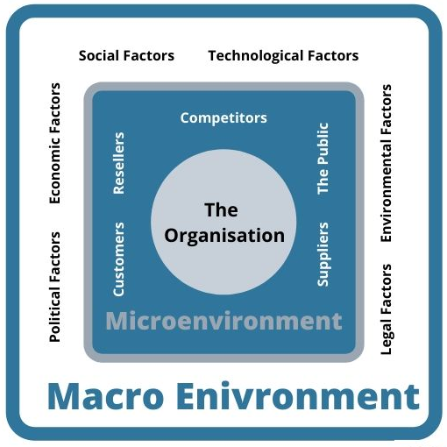
Figure no. 1. The Micro and Macro-environment of the enterprise
Source: Oxford College of Marketing, 2014

Equations and formulas should be wrote using the equation editor and numbered. The numbers are to be justified to the right, within parentheses.
Example of equation:
 | $$NPV=-I+\sum_{k=0}^{t}{\frac{{AF}_{k}}{{(1+i)}^{k}}+\frac{R_{t}}{{(1+i)}^{t}}}$$ | (1)
where:
NPV = Net Present Value
I = Investment
k = the number of the period (i.e., year)
AF = cash in – cash out for the period
R = residual value
i = discount rate
Abbreviations and acronyms should be defined the first time they are used in the text. If you use many abbreviations and acronyms, you should provide an alphabetical list of their definitions.

Examples of abbreviations and acronyms:
agr. – agriculture
biol. – biology
cyb. – cybernetics
ec. – economy
IT – information technology
CEEC – Central and Eastern Europe Countries
CSR – Corporate Social Responsibility
GMES – Global Monitoring for the Environment and Security
MRA – Mutual Recognition Agreement

Conclusions
A conclusion section is required. Conclusions should provide a synthesis of the main contributions of the paper, discuss the importance of the work, and/or suggest possible applications and extensions of the research.

Acknowledgement(s): (optional)

References
In the references list, at least 50% of the bibliographic sources must be from publications indexed by Web of Science.
BASIQ Conference requires the Harvard referencing style, developed by Anglia Ruskin University. The referencing style can be accessed here: https://library.aru.ac.uk/referencing/harvard.htm
Example:
Blau, P.M., 1964. Exchange and Power in Social Life. New York: John Wiley.
Brouder, P., 2018. The end of tourism? A Gibson-Graham inspired reflection on the tourism economy. Tourism Geographies, 20(5), pp.916-918.
Dilchert, S., Ones, D.S., Davis, R.D. and Rostow, C.D., 2007. Cognitive ability predicts objectively measured counterproductive work behaviors. Journal of Applied Psychology, 92(3), pp.616-627. https://doi.org/10.1037/0021-9010.92.3.616.
The New York Times, 2020. Coronavirus Travel Restrictions, Across the Globe, [online] Available at: <https://www.nytimes.com/article/coronavirus-travel-restrictions.html> [Accessed 17 August 2020].

